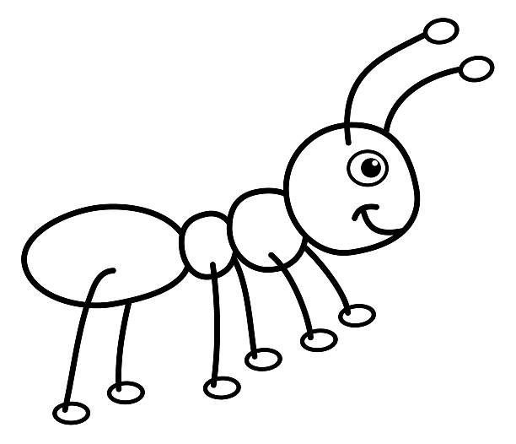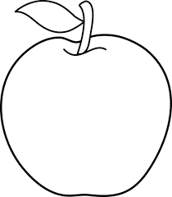Color and write:

**Aa**

**ant**

**Apple**

A A a a

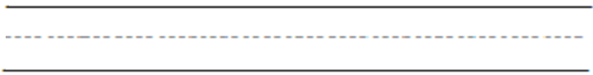

A A a a \AA

A A a a \AA

